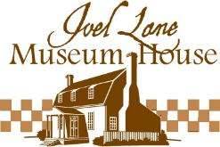
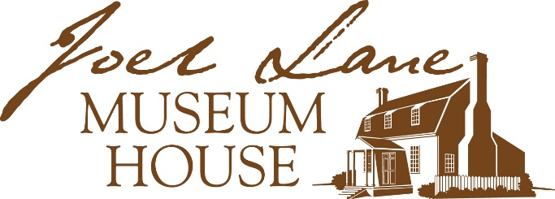

Yes, I want to have a brick paver inscribed to support
Joel Lane Museum House’s Commemorative Brick Campaign!

Name _______________________________________
Address _____________________________________
City, State, Zip _______________________________
Phone _______________________________________
Email _______________________________________

___Number of pavers @ $85 $____________
I’d like to make an additional donation of $____________
Total enclosed $____________
I would like to pay by _____Check or ______MasterCard or Visa

Please list all digits from your credit card

Expiration Date Security code from back of card

Signature___________________________________________
Note: A 1% convenience fee will be added to card-not-present orders.
Per paver engraving desired—limit: three lines of text and 17 characters (including spaces and punctuation) per line. (Attach additional sheet if more than one paver is desired.)

___ ___ ___ ___ ___ ___ ___ ___ ___ ___ ___ ___ ___ ___ ___ ___ ___ (Limit 17 letters, spaces, and
punctuation
___ ___ ___ ___ ___ ___ ___ ___ ___ ___ ___ ___ ___ ___ ___ ___ ___ per line)

___ ___ ___ ___ ___ ___ ___ ___ ___ ___ ___ ___ ___ ___ ___ ___ ___

Mail to: Joel Lane Museum House
P O Box 10884
Raleigh NC 27605
Questions? Phone the office at 919-833-3431 or email joellane@bellsouth.net.
Financial information about this organization and a copy of its license are available from
the State Solicitation Licensing Branch at 888-830-4989.

